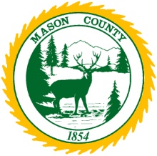
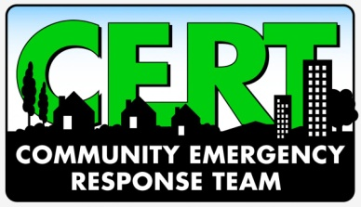
Mason County Community Emergency Response Team (CERT)
Volunteer Training Opportunity (2021)
__________________________________________________________________
The Mason County CERT program educates volunteers about disaster preparedness and how to respond to emergency situations in their community. When emergencies happen, CERT members can give critical support to first responders and provide immediate assistance to victims at a disaster site.

CERT is a twenty-hour training program that prepares you to help yourself, family, neighbors, and co-workers in the event of a disaster. To receive a class completion certificate, you must attend all twenty-hours of training.

If you are interested in attending the next class, please fill out the form below and send to Mason County Division of Emergency Management (DEM), 100 W. Public Works Drive, Shelton, WA 98584 or e-mail: MCDEM@MasonCountywa.gov
DATES/TIMES

LOCATION: Hoodsport Fire Station
Hoodsport, WA
Friday, March 29, 2024, 6:00–9:00 PM | Saturday, March 30, 2024, 8:00 AM–5:00 PM
Friday, April 5, 2024, 6:00–9:00 PM | Saturday, April 6, 2024, 8:00 AM–5:00 PM
MASON COUNTY CERT TRAINING REQUEST FORM
(Please print or type the following information and send it to Mason County DEM)

NAME:___________________________________________________________________________

ADDRESS:_______________________________________________________________________

CITY:________________________________________ STATE:________ ZIP CODE_____________

(AREA CODE) PHONE: _________________________ E-MAIL: ______________________________

- Minimum age is 18 unless Parents or Guardians attend class also.
- All information is confidential.
- You will receive further class schedule information and registration materials in the mail.
- Thank you for your interest in the Mason County CERT Program.

Mason County Division of Emergency Management (DEM) 100 W. Public Works Drive, Shelton, WA 98584 360-427-7535, e-mail: MCDEM@MasonCountywa.gov

